READ ME:

Table of Contents

1. Source Code
   1. Sentimental_Analysis_Final.py (Python code which runs the sentimental analysis)
   2. Templates (HTML and CSS files for the UI)
2. Output
   1. Home page (Home page for the UI)
   2. Pie chart of NLP (Result generated by the python program by NLP classifier)
   3. Pie chart of Naïve Bayes (Result generated by Naïve Bayes classifier)
   4. Pie chart of SVM (Result generated by SVM classifier)
   5. Final Result (Integrating all the results and displaying in the UI)
3. Training and Test Data Set
   1. ProcessedPositive.csv (list of positive tweets)
   2. ProcessedNegative.csv (list of negative tweets)
   3. ProcessedNeutral.csv (list of neutral tweets)
   4. TestDataFile.csv (list of tweets generated by Twitter API) NOTE: this file creates in real time, based on the input given by the user.
4. Final Project Report cpsc531.docx
5. Self Evaluation Report
6. Sentimental Analysis of Twitter Data-cpsc481(PowerPoint Presentation)

Steps to run the project:

Step 1: Getting the authentication credentials

* 1. First off, we need to visit the Twitter Developer website and log into our account through the following link:
  2. [Twitter Developer Platform : developer.twitter.com](https://developer.twitter.com/content/developer-twitter/en.html)
  3. On the top-right corner, click on the Apps button, Create an App, Apply and then Continue, as shown below:



* 1. Next, we will choose the “I am requesting access for my own personal use” option:

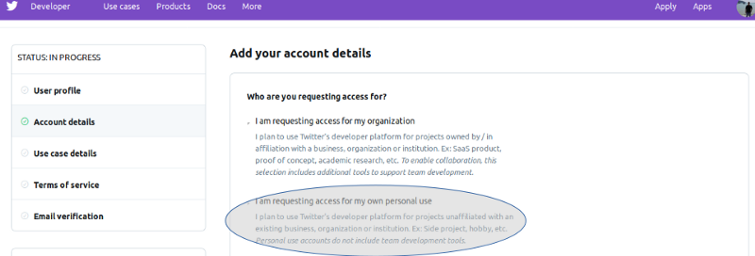

* 1. On the same web page, scroll-down a bit and input your Account name and Country of operation then click Continue, and you will be redirected to the next web page. Here, you can choose any Use Cases you’re interested in. For our case, I chose the following:

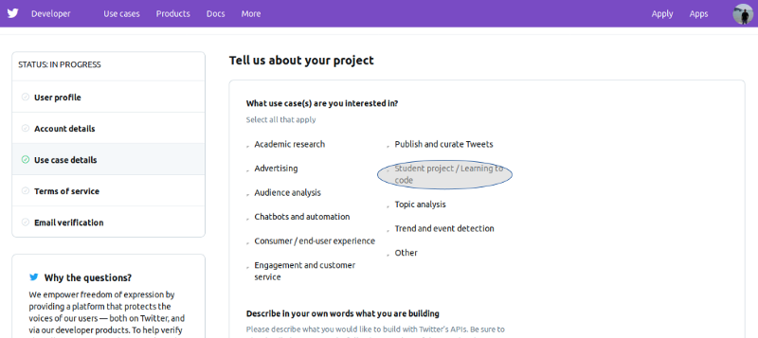

* 1. After you make your choice, scroll-down and fill out the use case interest paragraph required. Twitter takes this very seriously now (guess they learned from Facebook’s mistakes xD), so make sure you emphasize on the application being a self-learning/academic-related project. Choose “No” for the government involvement question, and press “Continue”.
  2. On the next web page, read the Terms and Conditions list, Agree to them then Submit Application.
  3. Next, open your email and verify your Twitter Developer account through the link included in the email sent to you. Finally, you will get a message similar to the following:
  4. 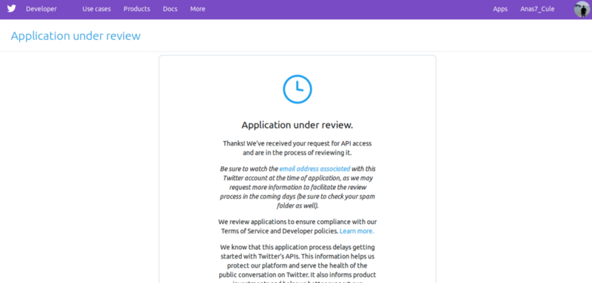
  5. All you can do now is wait for a few hours for the application to be approved (which almost certainly will, if your explanation did not violate Twitter’s terms and conditions).
  6. When you get the approval email, click on the login link it contains. You will be redirected to the following web page, where you should choose “Create an app”:

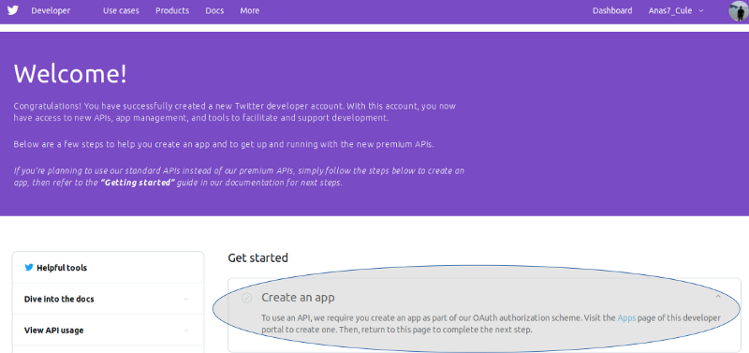

* 1. On the next web page, click “Create an app” from the top-right corner. After you are redirected, fill out the required app details, including — if you’d like — that it is for self-learning purposes. Click “Create”.
  2. The next web page will include the app details that you just input, access tokens and permissions. Proceed to the “Keys and tokens” tab. Copy the API key as well as the API secret key into a safe place (a text file, if you’d like), as we will be using them in a bit.

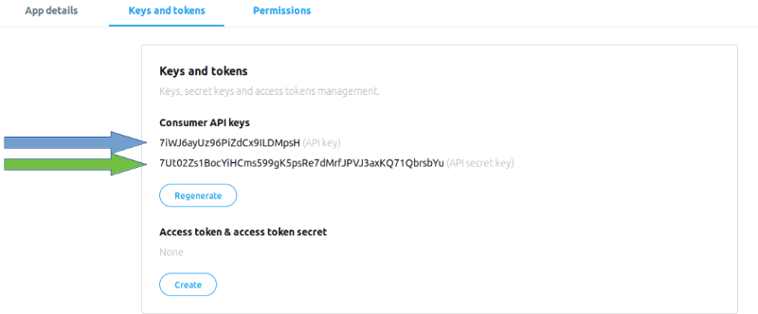

* 1. Once you’re all set, click “Create” to generate the Access token credentials. Copy the Access token and the Access token secret into a safe place as well. We’re done with the credential acquisition part!

Step2: Use the AccessToken credentials to place in the Sentimental_Analysis_final_for submission.py file as mentioned below:

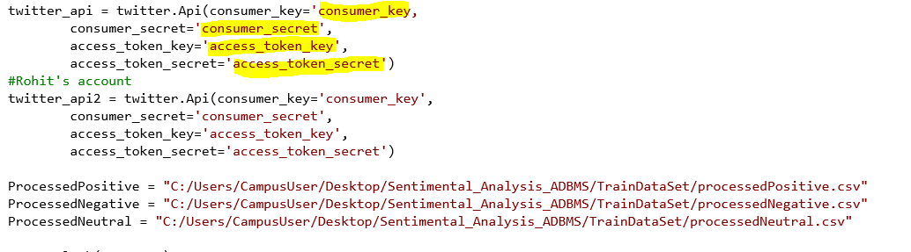

Step 3: Download the training data set and alter the ProcessedPositive, ProcessedNegative and ProcessedNeutral variables in the file to appropriately point to the destination of the files

Step 4: In terminal we need to install python-twitter. Command mentioned below:

Pip install python-twitter

Step 5: Execute the python program and render the url to an internet explorer.  
 results would automatically follow.

Refer to the attached video for details:

